C:\Users\joseph\AppData\Local\Microsoft\Windows\Temporary Internet Files\Content.IE5\6717ZPVW\MC900215303[1].wmf **St. Mary’s Academy**

**2017 Ski Club**

**Come Join St. Mary’s Academy for a Learn to Ski/Board Program offered through Blandford Ski Area. This program runs 6 consecutive Friday’s beginning the first Friday in January.**

**The nights are January 6, 13, 20, 27 and February 3, 10**

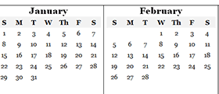

**You can see the pricing on St. Mary’s website.**

**Friends and Family of Academy are all welcome to join us.**

**There will be a sign up table at the play both nights December 8th & 9th. You can always complete the registration form along with the waiver and attach your check or checks. Feel free to contact me with any questions.**

**Registration deadline is: December 14, 2016**

**Contact information for the club coordinator Tina Malley:  
413-575-2572 or email** [**tina@springfieldspring.com**](mailto:tina@springfieldspring.com)